**Homework**

Create and automation test with Selenium IDE for:

• Login positive using assertion

• Logout positive using assertion

Once we have Selenium IDE installed (as an application in the browser), it will be present in the browser extensions (and we can also pin it so it would be visible):

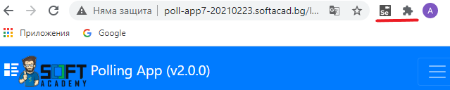

1. Click on Selenium icon (Se)

2 Create a new project >

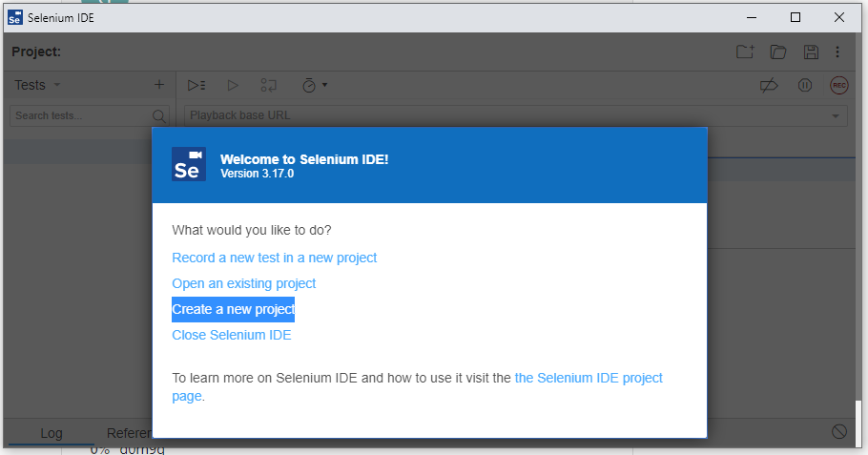

3 Enter Project Name (AUT login positive) >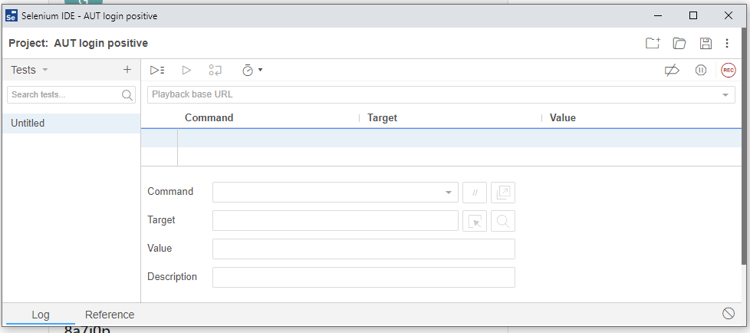

4. In the drop down menu, select “Test suites” and select the “+” to add new test suite (Logins).

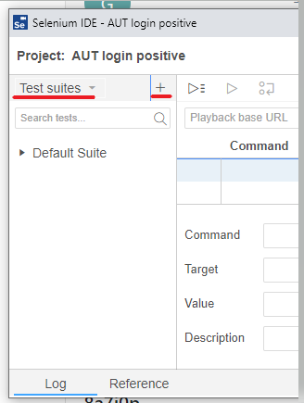

5. In the drop down menu, select “Tests” and select the “+” to add new test (login positive).

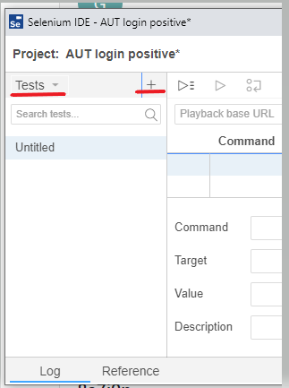

6. In the drop down menu, select “Test suites” and select the three dots to the right of the created suite to add new test suite (Logins).

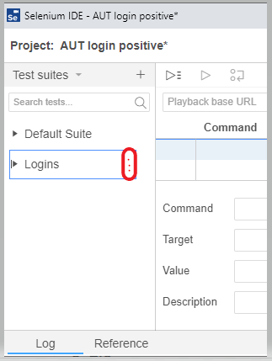

Choose the option add tests to add the test (login positive) to the test suite (Logins)

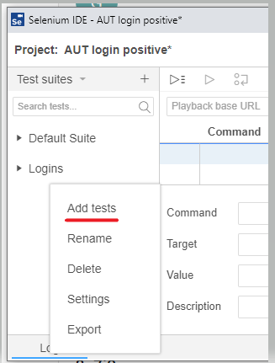

Now you can see the created case (login positive) under the created case suite (Logins):

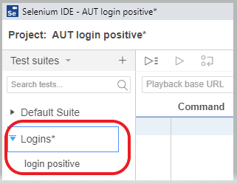

7. Add base URL under (Playback base URL) > then paste the cursor under in the blue field under Command, Target and Value to activate the Command, Target, Value and Description fields.

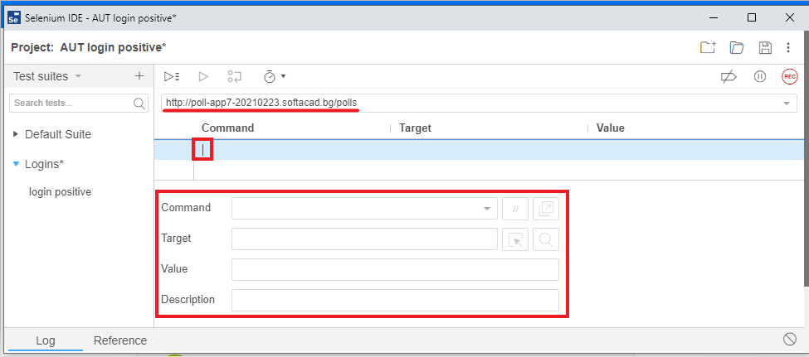

8. Then go to the AUT’s URL (<http://poll-app7-20210223.softacad.bg/polls>)

And start typing the commands to be executed:

-.1.Open the application:

**Command:** open

**Target:** <http://poll-app7-20210223.softacad.bg/polls>

-.2. Click on the “Login” button

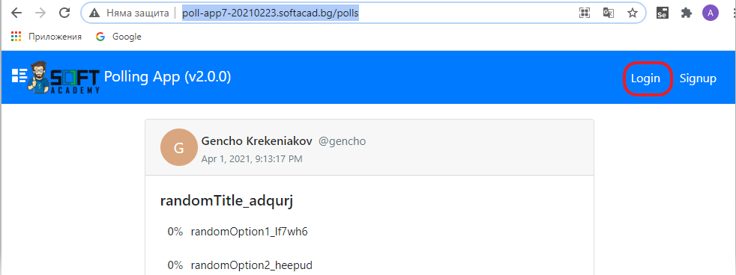

Go to the page, rights-click on the “Login” tab in the menu > Inspect

In the Inspector tool we can see that the “Login” is a button with id=”active”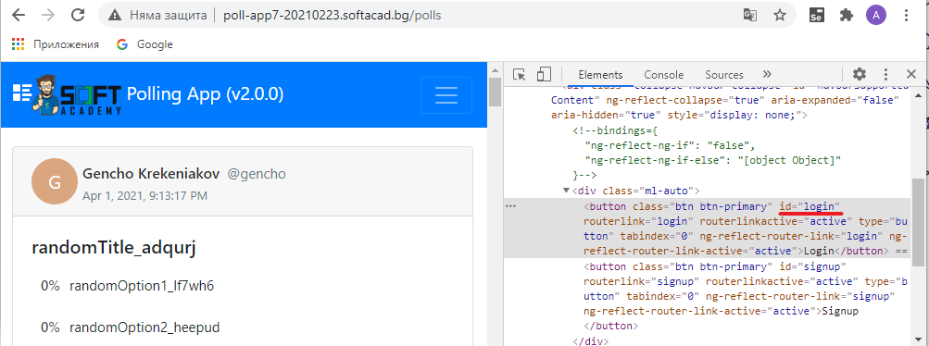

So we fill the fields:

**Command**: click

**Target:** id=login

Note: After adding each action (line of the test) we can run the test

-.3.Fill the “Username or Email” field

**Command:** type

**Target:** id=usernameOrEmail

**Value:** normalUser1

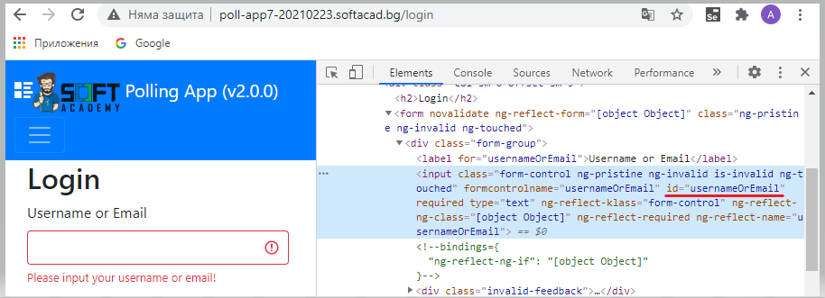

-.4.Fill the “Username or Email” field

**Command:** type

**Target:** id=password

**Value:** 123456

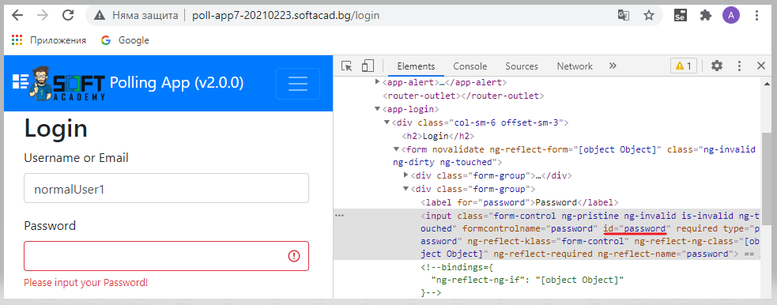

-.5.Fill the “Username or Email” field

**Command:** click

**Target:** name=login

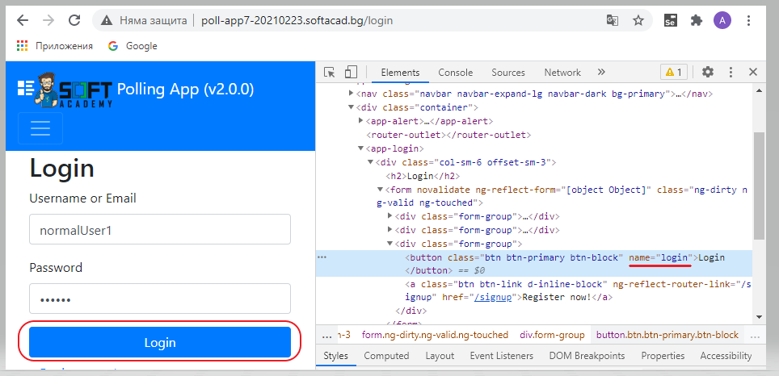

-.6.Check if we are logged in

**Command:** assert element present

**Target:** name=login

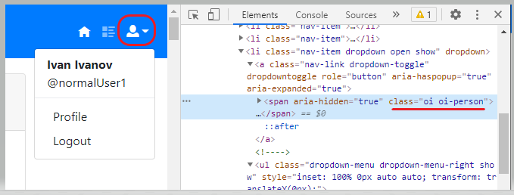

-.7.Click on the profile icon in order the logout option to be available for click

**Command:** click

**Target:** css=.oi-person

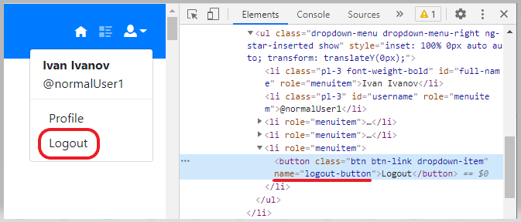

-.8.Check if we are logged out (redirected to the login page)

**Command:** assert element present

**Target:** id=login

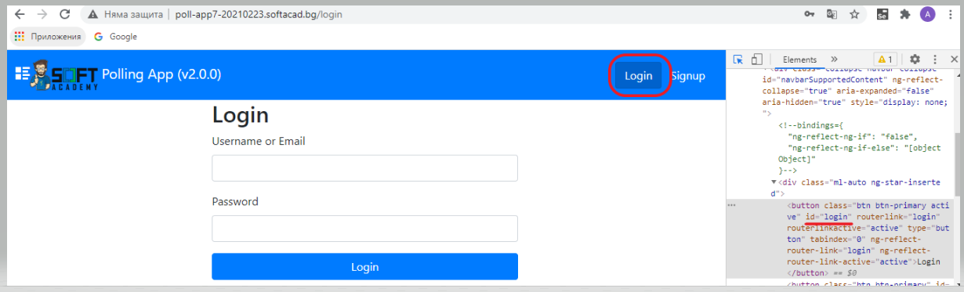

**Making some mistakes on purpose to check how the case will behave:**

In step 4 adding additional symbol (1234560 instead of 123456)

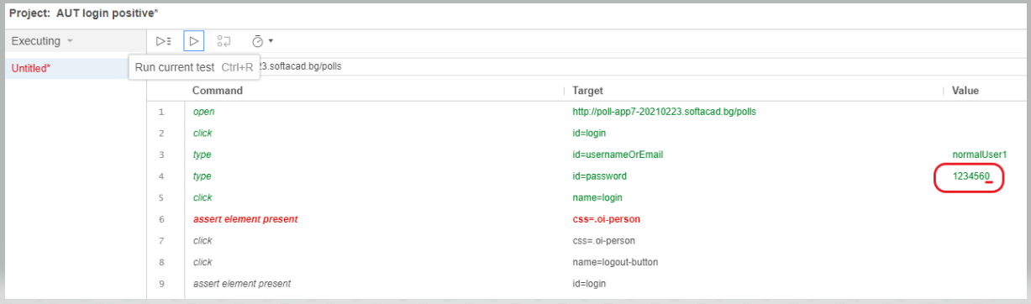

In step 7 adding a symbol at the end css=.oi-symbolo instead of css=.oi-symbol

